Development of an offline Point of Sale (POS) System for small businesses in Lesotho

A project submitted by
Mpho George Makaliana
01 June 2026
Supervisor: Mr. Thabiso

1. Theoretical Background
A Point of Sale (POS) system is a computerized business solution used to process sales transactions, manage stock, maintain supplier records, generate receipts, and produce business reports. Modern POS systems replace manual record-keeping methods, improving efficiency, accuracy, and decision-making.
This project is grounded in several Information Technology concepts including:
- Database Management Systems (DBMS)
- Inventory Management Systems
- Transaction Processing Systems
- Human-Computer Interaction (HCI)
- Software Engineering
- Systems Development Life Cycle (SDLC)
- ACID Properties (Transaction Integrity in Databases)
The system will implement ACID principles to ensure reliable and safe transaction processing:
- Atomicity: Each transaction (sale) is completed fully or not at all.
- Consistency: The database always remains in a valid state.
- Isolation: Multiple sales transactions do not interfere with each other.
- Durability: Completed transactions remain permanently stored even after system failure.
The proposed system will be developed using Python for application development, Tkinter for the graphical user interface, SQLite for data storage, Git and GitHub for version control and team collaboration, and PyInstaller for software deployment.
The system will operate entirely offline, making it suitable for small businesses in Lesotho where internet access may be unreliable or unavailable.

2. Problem Statement
Many small businesses in Lesotho still manage their daily operations using notebooks, calculators, and manual receipts.
For example, 'Maliteboho, a small restaurant owner in Maseru, records stock purchases, daily sales, and profits manually. As the business grows, it becomes increasingly difficult to determine:
- Current stock levels
- Daily sales performance
- Monthly profit or loss
- Fast-selling products
- Reorder requirements
Manual processes often result in calculation errors, lost records, inaccurate reporting, and poor business decisions.
There is therefore a need for an affordable and easy-to-use offline POS system specifically designed for small businesses in Lesotho.

3. Motivation
This project is motivated by the increasing need for affordable business management software among small businesses in Lesotho.
Many local businesses cannot afford expensive international POS systems and often lack reliable internet connectivity required by cloud-based solutions.
The proposed POS system seeks to provide a locally developed alternative that:
- Improves stock management.
- Automates sales recording.
- Generates accurate profit and loss reports.
- Reduces human errors.
- Saves time.
- Supports better business decision-making.
- Promotes local software innovation and entrepreneurship.
Additionally, the project provides an opportunity to apply software engineering principles to solve a real-world business problem.

4. Objectives and Scope of the Project

4.1 Objectives
The project aims to:
- Develop a fully offline POS system
- Implement secure login functionality
- Apply role-based access control (Admin and Cashier)
- Manage products and inventory
- Track stock levels automatically
- Generate low stock alerts
- Process cash sales
- Support barcode scanning
- Print receipts
- Manage supplier information
- Generate sales reports (daily/monthly)
- Calculate profit and loss automatically
- Implement data backup and restore functionality
- Maintain audit logs for transactions

4.2 Scope

Included Features (Version 1)

User Management
- User login
- User creation
- Admin and Cashier roles

Stock Management
- Add products
- Edit products
- Delete products
- Track stock quantities
- Low stock alerts

Sales Functionality
- Cash sales
- Barcode scanning
- Discount application
- Receipt printing
- Automatic stock updates

Supplier Management
- Add suppliers
- Edit suppliers
- View suppliers

Reporting
- Daily sales reports
- Monthly sales reports
- Current stock reports
- Daily profit reports
- Monthly profit/loss reports

Hardware Support
- Desktop computer
- Barcode scanner
- Receipt printer
- Cash drawer

Excluded Features (Future Versions)
- Credit sales
- Lay-buy functionality
- Mobile money integration
- Online payments
- Customer management
- Multi-branch support
- Cloud synchronization

5. Detailed System Requirements

5.1 Functional Requirements
The system shall:
- Allow authorized users to log in.
- Allow administrators to add users.
- Add, edit, and delete products.
- Track stock levels automatically.
- Display low stock warnings.
- Process cash sales.
- Apply discounts to sales.
- Print customer receipts.
- Manage supplier information.
- Generate daily sales reports.
- Generate monthly sales reports.
- Generate daily profit/loss reports.
- Generate monthly profit/loss reports.

5.2 Non-Functional Requirements
The system shall:
- Operate without internet access.
- Be user-friendly.
- Provide fast response times.
- Store data securely.
- Support future enhancements.
- Run on Windows desktop computers.
- Maintain data integrity and reliability.

6. High-Level System Design

System Architecture

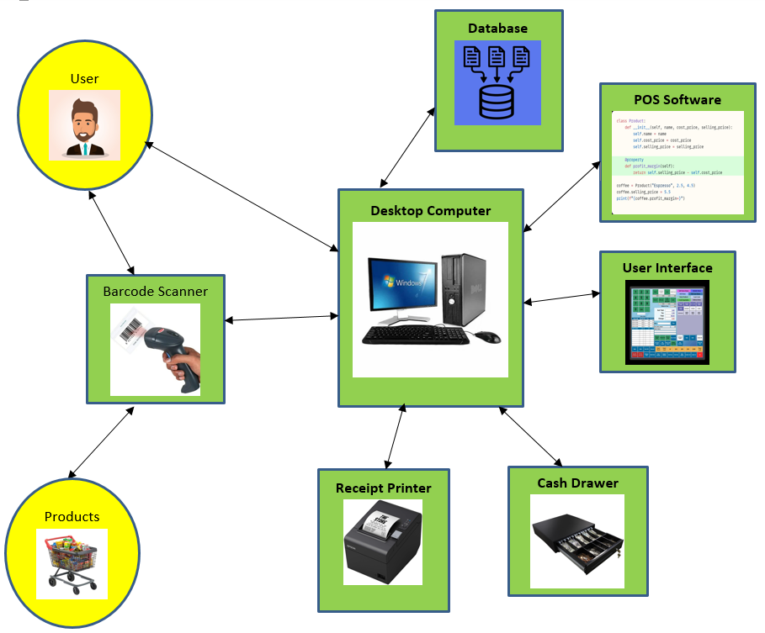

Explanation
Barcode Scanner
- Reads product barcodes.
- Sends barcode data to the desktop computer.
Desktop Computer
- Hosts all software components.
- Acts as the central processing unit of the POS system.
User Interface
- Allows the cashier to interact with the system.
- Displays products, cart contents, totals, and sales information.
POS Software (Business Logic)
- Processes barcode inputs.
- Searches for products.
- Calculates totals, discounts, and change.
- Records sales transactions.
- Updates inventory levels.
Database
- Stores products, users, stock quantities, and sales records.
- Provides data to the POS software when requested.
Receipt Printer
- Prints receipts after successful transactions.
Cash Drawer
- Opens automatically after cash payments are completed.

System Flow Explanation

Step 1: Product Scanning
The cashier scans a product using the barcode scanner. The scanner attempts to read the barcode and send the barcode number to the POS software.

Step 2: Barcode Successfully Read?

If Yes
The barcode is sent to the POS software, which searches the database for the corresponding product information.

If No
The system displays an error message such as:
"Barcode could not be read. Please scan again."
The cashier can:
- Reposition the product and scan again.
- Clean or inspect the barcode if it is damaged.
- Enter the barcode manually using the keyboard.
- Search for the product by name or product code if manual product search is available.
Once a valid barcode or product is entered, the process continues normally.

Step 3: Product Found in Database?

If Yes
The database returns the product details and the item is added to the sales cart.

If No
The system displays:
"Product not found."
The cashier may:
- Verify the barcode.
- Search for the product manually.
- Request assistance from the administrator to add the product to inventory.

Remaining Steps
The system then continues with:
- Adding products to the cart.
- Calculating the total.
- Receiving payment.
- Recording the transaction.
- Updating inventory.
- Printing the receipt.
- Opening the cash drawer.
- Storing transaction data.

System Flow Diagram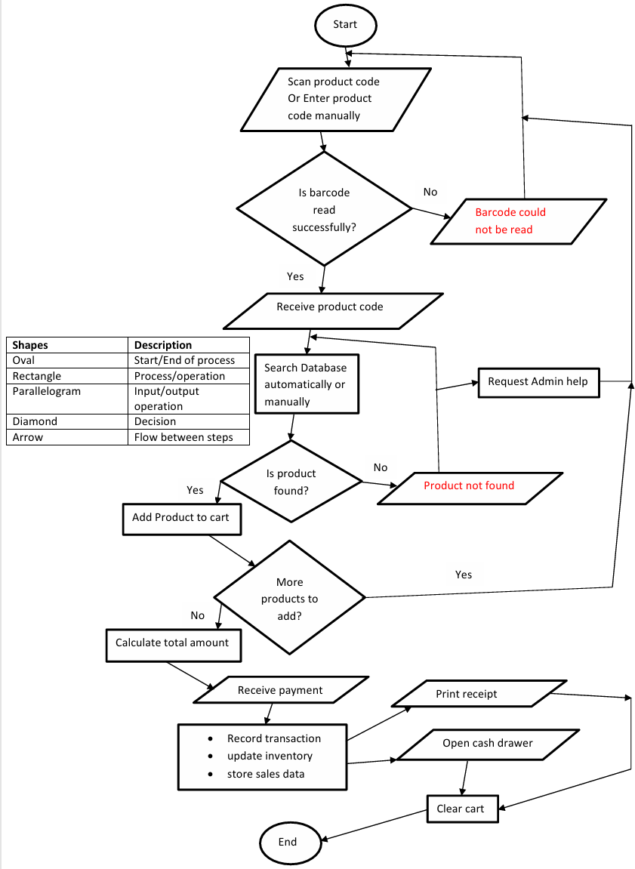

7. DATABASE DESIGN
The POS system uses a relational database to organize and store data efficiently. The selected tables support the core business operations of user management, inventory management, supplier management, sales processing, and reporting.

7.1 Database Tables

Users Table
Stores information about people who can access the system, such as administrators and cashiers.
Field | Description
user_id (PK) | Unique identifier for each user
username | User login name
password_hash | Encrypted password for security
role | User role (Admin or Cashier)
created_at | Date and time the account was created
Reason for Inclusion
This table enables user authentication, role-based access control, accountability, and audit tracking. Every sale can be linked to the user who processed it.

Products Table
Stores all products available for sale.
Field | Description
product_id (PK) | Unique product identifier
product_name | Name of product
barcode | Product barcode
cost_price | Purchase cost of product
selling_price | Selling price to customers
quantity_in_stock | Current stock quantity
supplier_id (FK) | Supplier providing the product
Reason for Inclusion
This table supports inventory management, barcode scanning, stock monitoring, pricing, and profit calculations.

Sales Table
Stores summary information for each completed sale.
Field | Description
sale_id (PK) | Unique sale identifier
user_id (FK) | User who processed the sale
total_amount | Total before discounts
discount | Discount applied
final_amount | Final amount paid
date_time | Date and time of transaction
Reason for Inclusion
This table records every transaction and provides data required for daily sales reports, monthly sales reports, and profit analysis.

Sales_Transactions Table
Stores individual products sold within a sale.
Field | Description
transaction_id (PK) | Unique transaction identifier
sale_id (FK) | Related sale
product_id (FK) | Product sold
quantity | Quantity purchased
price | Selling price at time of sale
Reason for Inclusion
A customer may buy multiple products in one sale. This table captures the detailed line items of each transaction and allows accurate receipt generation and sales analysis.

Suppliers Table
Stores supplier information.
Field | Description
supplier_id (PK) | Unique supplier identifier
supplier_name | Supplier name
phone | Supplier contact number
address | Supplier address
Reason for Inclusion
This table helps track where products come from and simplifies stock replenishment and supplier management.

7.2 Relationships
The database tables are connected using primary keys (PK) and foreign keys (FK) to maintain data integrity and avoid duplication

1. One User → Many Sales
Relationship Type: One-to-Many (1: M)
A single user can process many sales, but each sale is processed by only one user.
Example
Cashier1:
- Sale #1001
- Sale #1002
- Sale #1003
Admin:
- Sale #1004
- Sale #1005

2. One Sale → Many Sales_Transactions
Relationship Type: One-to-Many (1: M)
A single sale can contain many products, resulting in multiple transaction records.
Example
Sale #1001:
- Bread × 2
- Milk × 1
- Sugar × 3
These items are stored as separate records in the Sales_Transactions table.

3. One Product → Many Sales_Transactions
Relationship Type: One-to-Many (1: M)
A product may appear in many different sales over time.
Example
Bread may be sold:
- Today
- Tomorrow
- Next week
Each occurrence creates a separate Sales_Transactions record.

4. One Supplier → Many Products
Relationship Type: One-to-Many (1: M)
A supplier can provide multiple products, but each product is linked to one supplier.
Example
Supplier A:
- Bread
- Milk
- Eggs
Supplier B:
- Soft Drinks
- Water

Entity-Relationship Diagram

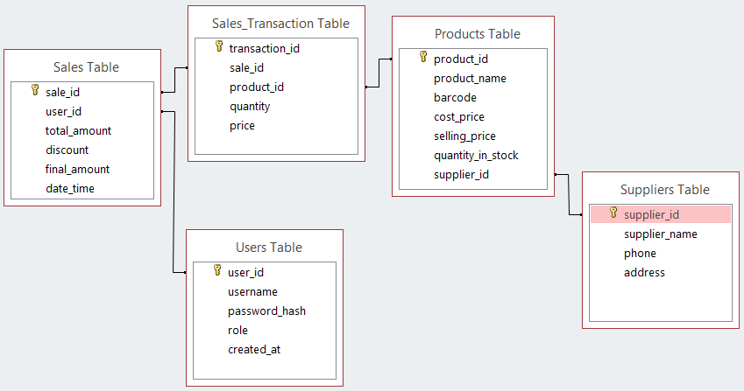

Relationship Summary
Relationship | Type
User → Sales | One-to-Many (1:M)
Sale → Sales_Transactions | One-to-Many (1:M)
Product → Sales_Transactions | One-to-Many (1:M)
Supplier → Products | One-to-Many (1:M)
There are no One-to-One (1:1) relationships in this design because each major business entity naturally relates to multiple records in another table. The design is normalized, minimizes data redundancy, and supports efficient reporting, inventory management, and sales processing.

8. Tools and Technologies to Use
Component | Technology
Programming Language | Python
Graphical User Interface | Tkinter
Database | SQLite
Version Control | Git
Repository Hosting | GitHub
Packaging Tool | PyInstaller
Documentation | Microsoft Word
Operating System | Windows
Code Editor | Visual Studio Code (VS Code)
Entity-Relationship (ER) Diagram | Microsoft Access
System Architecture | Microsoft Word
System Flow Diagram | Microsoft Word
Gantt Chart (Project Schedule) | Microsoft Excel
Low-fidelity Prototype | Draw.io Diagrams
Screen Recording Video updates | Snipping Tool
Graphs Reporting | Matplotlib

Why These Technologies Were Chosen

Python
Python will be used to develop the application logic. It is easy to learn, widely supported, and enables rapid software development.

Tkinter
Tkinter will be used to create graphical user interfaces such as forms, menus, buttons, and reports. It is lightweight and included with Python at no additional cost.

SQLite
SQLite will store all business data including products, sales, suppliers, and users. It was chosen because it is lightweight, fast, reliable, and works completely offline.

Git
Git will track project changes and allow multiple developers to work on the project simultaneously without losing work.

GitHub
GitHub will host the project repository online, allowing collaboration, backup, and project management.

PyInstaller
PyInstaller will convert the Python application into a Windows executable (.exe) that can be installed on customer computers.

Microsoft Word
Microsoft Word will be used to prepare project reports, user manuals, technical documentation, and installation guides.

Windows Operating System
Windows was selected because it is the most commonly used operating system among small businesses and supports the required POS hardware devices.

Visual Studio Code (VS Code)
VS Code will be used as the primary development environment. It provides syntax highlighting, debugging tools, Git integration, project navigation, and extension support, making software development faster and more organized. It is also free and widely used by professional developers.

Microsoft Access
Microsoft Access is used for Entity-Relationship (ER) Diagram because is free as it comes with Microsoft package of Windows 10 Operating System and it instantly transitions conceptual design into a functional, working database.

System Architecture

Microsoft Word is used for drawing System Architecture because it is easy to use and cheap since it comes with Microsoft package of Windows 10 Operating System.

System Flow Diagram

Microsoft Word is used for drawing System Flow Diagram because it is easy to use and cheap since it comes with Microsoft package of Windows 10 Operating System.

Low-Fidelity Prototype

Draw.io Diagrams is used for drawing Low-Fidelity Prototype because it is easy to use.

Gantt Chart (Project Schedule)

Microsoft Excel is used for drawing Project Schedule because it is easy to use and cheap since it comes with Microsoft package of Windows 10 Operating System.

Snipping Tool (Screen Recording Video updates)

Snipping Tool is used for screen recording video updates because it is easy to use and cheap since it comes with Windows 10 Operating System.

Matplotlib Library (Graphs Reporting)

Matplotlib is the most reliable, controllable, offline-ready visualization engine for Python desktop systems, and it integrates perfectly with Tkinter, making it ideal for embedded dashboards like my POS system, where I need simple reports and full offline functionality without external dependencies.

9. Project Schedule
The project is planned over seven months, allowing sufficient time for analysis, design, development, testing, deployment preparation, and post-deployment improvements.

Month 1(June): Analysis and Planning

Activities
- Gather and analyze user requirements.
- Study existing Point of Sale (POS) systems.
- Define project scope and objectives.
- Identify functional and non-functional requirements.
- Set up version control using Git and GitHub.

Explanation
This phase focuses on understanding the needs of business owners, cashiers, and administrators. The project requirements are documented, project boundaries are defined, and development tools are prepared to ensure an organized software development process.

Month 2 (July): System Design

Activities
- Design the database structure (tables, keys, and relationships).
- Design user interfaces and screen layouts.
- Create the overall system architecture.
- Design workflows and system processes.
- Define security and role-based access mechanisms.

Explanation
This phase serves as the blueprint for the system. The database, user interfaces, and system architecture are carefully designed to ensure that all components work together efficiently and securely.

Month 3 (August): Core System Development

Activities
- Develop the login and authentication system.
- Implement role-based access control (Admin and Cashier).
- Develop user management functionality.
- Develop product management functionality.

Explanation
This phase establishes the core foundation of the POS system. Users will be able to securely log in, administrators will manage system users, and products can be added, updated, viewed, and deleted.

Month 4 (September): Inventory and Supplier Management Development

Activities
- Develop stock tracking functionality.
- Implement low-stock alert mechanisms.
- Develop supplier management module.
- Design and implement the initial data backup strategy.

Explanation
The system begins managing inventory levels and supplier information. Automated stock monitoring helps prevent stock shortages, while backup planning ensures business data can be protected and recovered when necessary.

Month 5 (October): Sales System Development

Activities
- Develop sales processing functionality.
- Integrate barcode scanning capabilities.
- Implement receipt generation and printing.
- Implement automatic stock deduction after sales.
- Implement ACID-compliant transaction handling to ensure transaction integrity.

Explanation
This phase enables the system to process real customer purchases. Products can be scanned, added to a cart, sold, and recorded. ACID transaction handling ensures that sales are processed reliably and consistently, preventing data corruption or incomplete transactions.

Month 6 (November): Reporting, Testing, and Backup Implementation

Activities
- Develop the reporting module.
- Implement profit and loss calculations.
- Conduct unit testing.
- Conduct integration testing.
- Perform User Acceptance Testing (UAT).
- Implement backup and restore functionality.
- Prepare system documentation.
- Create deployment and installation packages.

Explanation
This phase ensures that all modules work correctly both individually and together. Comprehensive testing is conducted to identify and fix defects before deployment. Backup and restore features are finalized to safeguard business data.

Month 7 (December): Maintenance and Feedback Loop

Activities
- Collect feedback from users.
- Fix identified bugs and issues.
- Improve system performance.
- Refine user interface and user experience (UI/UX).
- Release Version 1.1 improvements.

Explanation
After initial deployment, feedback from actual users is gathered to identify areas for improvement. Necessary fixes and enhancements are implemented, ensuring the system remains reliable, user-friendly, and aligned with business needs.
Gantt Chart (shows project schedule)

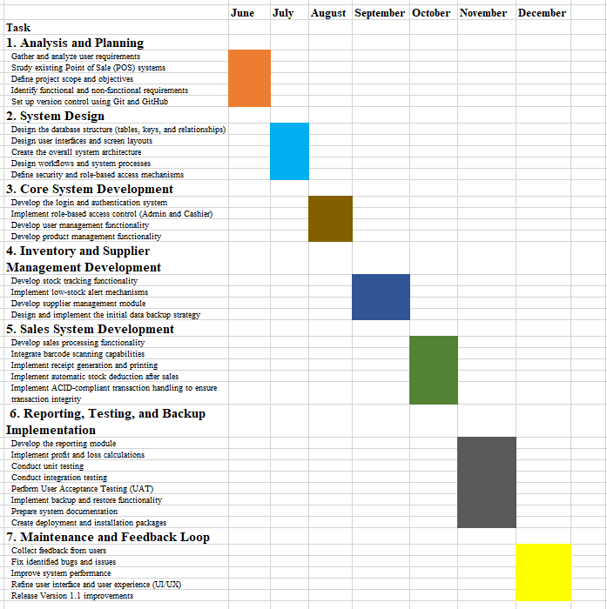

Project Timeline Summary
Month | Phase
Month 1 | Analysis and Planning
Month 2 | System Design
Month 3 | Core System Development
Month 4 | Inventory and Supplier Management
Month 5 | Sales System Development
Month 6 | Reporting, Testing and Backup Implementation
Month 7 | Maintenance and Feedback Loop
This schedule follows a logical progression from requirements gathering through design, development, testing, deployment preparation, and continuous improvement, increasing the likelihood of delivering a reliable and maintainable POS system.

10. Low-Fidelity Prototype
The following prototypes illustrate how different users interact with the POS system, including role behavior, cashier functionality, and full system flows for both Admin and Cashier.

A. Login Screen
POS SYSTEM
--------------------------------
Username: ____________
Password: ____________
[ LOGIN ]
--------------------------------
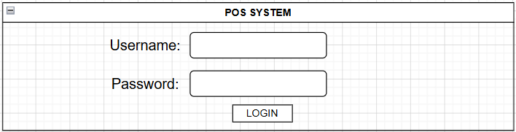
Purpose
Authenticates users and directs them to the correct dashboard based on role (Admin or Cashier).
Functional Requirement Covered
✔ User authentication
✔ Role-based access control
Latest update Begin
Your updates improve the practicality of the POS system significantly. Below is the refined version.

B. Admin Dashboard
ADMIN DASHBOARD
------------------------------------------------

[ Sales ]
[ Products ]
[ Suppliers ]
[ Reports ]
[ Users ]
[ Settings ]
[ Logout ]

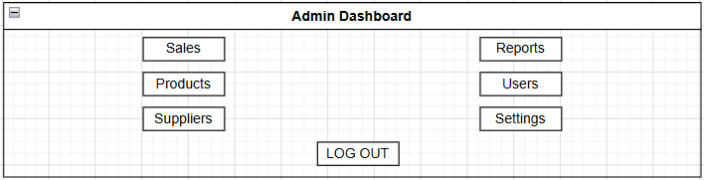

Purpose
Full system control interface for administrators.

Admin Access Rights
✔ Process sales
✔ Allow newly created admins to change temporary passwords after first login
✔ Manage products
✔ Manage suppliers
✔ Manage users
✔ View reports
✔ Configure system settings
✔ Reprint receipts

System Settings Configuration
The administrator will be able to configure:

Business Information
✔ Business Name
✔ Business Address
✔ Business Phone Number
✔ Business Email
✔ Receipt Header/Footer Information

Security Settings
✔ Change own password
✔ Set password policies
✔ Force first-time password change
✔ Enable/disable user accounts

Sales Settings
✔ Default VAT/Tax Rate
✔ Default Discount Rules
✔ Currency Format
✔ Receipt Number Format

Inventory Settings
✔ Low Stock Alert Threshold
✔ Automatic Stock Warning Notifications
✔ Product Barcode Settings

Backup & Recovery Settings
✔ Create Manual Database Backup
✔ Restore Database Backup
✔ Configure Automatic Backup Schedule

Receipt Settings
✔ Receipt Header
✔ Receipt Footer
✔ Company Logo
✔ Print Settings

System Preferences
✔ Date Format
✔ Time Format
✔ System Theme (optional)
✔ Language Settings (future enhancement)

C. Cashier Dashboard
CASHIER DASHBOARD
------------------------------------------------

[ New Sale ]
[ Search Product ]
[ Logout ]

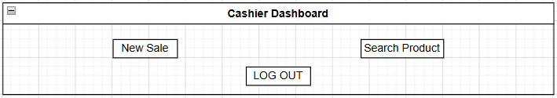

Purpose
Provides a minimal, fast interface strictly for sales processing operations.

Cashier Access Rights
✔ Process sales (New Sale)
✔ Search products (manual lookup or barcode fallback)
✔ Logout
✔ Allow newly created cashiers to change temporary passwords after first login
❌ Cannot view reports
❌ Cannot reprint receipts
❌ Cannot manage products
❌ Cannot manage suppliers
❌ Cannot manage users
❌ Cannot access system settings

D. Product Management Screen
PRODUCT MANAGEMENT
--------------------------------------------------------------------

| Product Name | Barcode | Cost Price | Selling Price |
| Quantity | Supplier |
--------------------------------------------------------------------

| Bread | 123456 | M10 | M15 | 100 | ABC Foods |
| Milk | 789456 | M15 | M20 | 80 | Dairy Ltd |
| ... |

--------------------------------------------------------------------

Product Name: ____________
Barcode: ____________
Cost Price: ____________
Selling Price: ____________
Quantity: ____________
Supplier: ____________

[ Add ] [ Update ] [ Delete ]

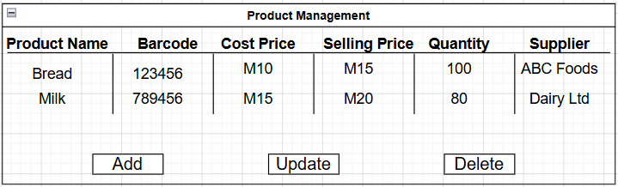

Purpose
Controls inventory and product data.

Functional Requirements Covered
✔ View all products
✔ Add products
✔ Update products
✔ Delete products
✔ Stock tracking
✔ Supplier association

E. Supplier Management Screen
SUPPLIER MANAGEMENT
--------------------------------------------------------------------

| Supplier Name | Phone Number | Address |
--------------------------------------------------------------------

| ABC Foods | 58000001 | Maseru |
| Dairy Ltd | 58000002 | Roma |
| ... |

--------------------------------------------------------------------

Supplier Name: ____________
Phone Number: ____________
Address: ____________

[ Add ] [ Update ] [ Delete ]

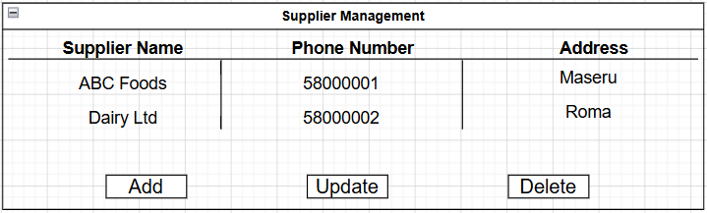

Purpose
Stores supplier information for procurement and business tracking.

Functional Requirements Covered
✔ View suppliers
✔ Add suppliers
✔ Update suppliers
✔ Delete suppliers

F. Sales Screen
SALES
----------------------------------------------------------------

Barcode: _______________________ Search Product: _______________________

----------------------------------------------------------------

| Product | Quantity | Unit Price | Subtotal |
----------------------------------------------------------------
| Bread | 1 | M15 | M15 |
| Milk | 1 | M20 | M20 |

----------------------------------------------------------------

Total: M35
Discount: M0
Final Total: M35

----------------------------------------------------------------

Amount Paid: ____________

Change: ____________

[ PAY ]

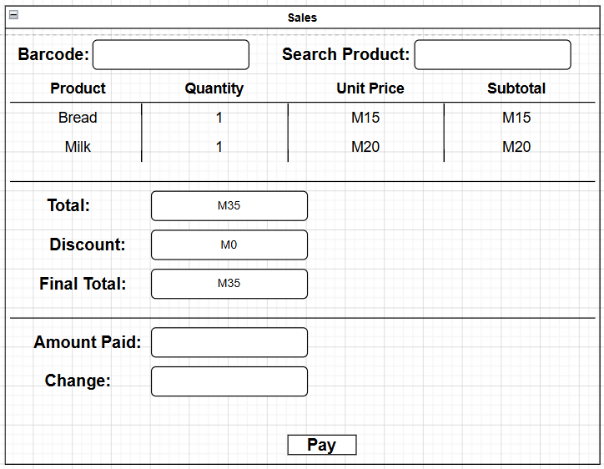

Purpose
Handles customer transactions in real time.

Functional Requirements Covered
✔ Barcode scanning
✔ Manual product search
✔ Cart management
✔ Discount handling
✔ Payment processing
✔ Stock update trigger
✔ Receipt generation

H. User Management Screen
USER MANAGEMENT
----------------------------------------------------------------------------

| Username | Role | Password Status |
----------------------------------------------------------------------------

| admin1 | Admin | Encrypted |
| cashier1 | Cashier | Encrypted |
| ... |

----------------------------------------------------------------------------

Username: ____________

Password: ____________

Role:

( ) Admin

( ) Cashier

[ Add User ] [ Update User ] [ Delete User ]

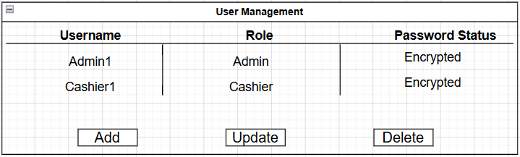

Purpose
Controls system access, roles, and permissions.

Functional Requirements Covered
✔ Create users
✔ Update users
✔ Delete users
✔ Role assignment
✔ Password encryption
✔ First-login password change enforcement

I. Updated Cashier Complete System Flow
START
|
v
Login Screen
|
v
Authentication Check
|
v
First Login?
|
+----Yes----> Change Temporary Password
| |
| v
| Save New Password
| |
+--------------------+
|
v
Cashier Dashboard
|
+-----------------------------+
| | |
v v v
New Sale Search Product Logout
|
v
Scan Barcode
|
+-----------------------------+
| Barcode Found? |
+-------------+---------------+
|
Yes | No
|
v
Retrieve Product
|
v
Add Item to Cart
|
v
Continue Shopping?
|
Yes ---+----> Scan/Search Next Item
|
No
|
v
Calculate Total
|
v
Apply Discount (if any)
|
v
Receive Payment
|
v
Save Transaction
|
+---------+---------+
| |
v v
Update Stock Print Receipt
|
v
Return to Dashboard

Cashier Flow Explanation
- Cashier logs into the system.
- System verifies credentials.
- If first login, cashier must change the temporary password.
- Cashier accesses the dashboard.
- Cashier starts a new sale.
- Products are added using barcode scanning or manual search.
- Multiple products may be added to the cart.
- System calculates totals and discounts.
- Customer pays.
- System:
  - Saves transaction
  - Updates inventory
  - Prints receipt
- Cashier returns to dashboard for the next customer.

J. Updated Admin Complete System Flow
START
|
v
Login Screen
|
v
Authentication Check
|
v
First Login?
|
+----Yes----> Change Temporary Password
| |
| v
| Save New Password
| |
+--------------------+
|
v
Admin Dashboard
|
+-------------------------------------------------------------+
| | | | | | |
v v v v v v v
Sales Products Suppliers Reports Users Settings Logout
| | | | | |
| | | | | |
| | | | | |
| Add/Update/ Delete Generate Create/ Configure
| Products Reports Manage System
| Users Settings
|
v
Process Sale (Optional)
|
v
Scan/Search Product
|
v
Add Item to Cart
|
v
Calculate Total
|
v
Receive Payment
|
v
Save Transaction
|
+------------+-------------+
| |
v v
Update Stock Print Receipt
|
v
Record Audit Trail
|
v
Return to Dashboard

Admin Flow Explanation
- Admin logs in and is authenticated.
- If using a temporary password, admin must change it after first login.
- Full administrative dashboard is displayed.
- Admin can:
  - Process sales
  - Manage products
  - Manage suppliers
  - Manage users
  - View reports
  - Configure system settings
- When a sale is processed:
  - Transaction is saved
  - Inventory is updated
  - Receipt is printed
  - Audit record is stored
- Reports assist management decision-making.
- Admin may return to the dashboard and continue with other tasks.

Audit Tracking Requirement
Every transaction must store:
- Sale ID
- Transaction Date
- Transaction Time
- User ID
- Username
- User Role (Admin/Cashier)
- Total Amount
- Discount Applied
- Final Amount Paid
- Payment Received
- Change Given
- Receipt Number

Purpose
Provides accountability, security, reporting accuracy, and traceability of all sales activities within the POS system.
Latest update End

12. Conclusion
This project proposes the development of an offline Point of Sale (POS) system tailored for small businesses in Lesotho.
The system will automate sales processing, inventory management, supplier tracking, and financial reporting while ensuring accuracy, efficiency, and reliability through proper database design and ACID transaction handling.
By replacing manual systems with a digital solution, the project aims to improve business efficiency and support local economic growth while demonstrating practical application of software engineering principles.

How to develop the remaining part of POS System:
ACID Transactions
↓
Stock Tracking
↓
Stock Deduction
↓
Sales Processing
↓
Barcode Integration
↓
Receipt Generation
↓
Low Stock Alerts
↓
Reporting Module
↓
Profit & Loss
↓
Backup Strategy

Phase 5: Barcode Integration
Add to Products table:
barcode TEXT UNIQUE
Add query:
database/queries.py
def get_product_by_barcode(barcode):
conn = get_connection()
cursor = conn.cursor()
cursor.execute("""
SELECT *
FROM Products
WHERE barcode=?
""",(barcode,))
product = cursor.fetchone()
conn.close()
return product
Workflow:
Barcode Scan
↓
Find Product
↓
Add To Cart
USB barcode scanners behave like keyboards.
No special library needed.

Phase 6: Receipt Generation
Create:
modules/sales/receipt_generator.py
import os
from datetime import datetime
def generate_receipt(
sale_id,
items,
total):
os.makedirs(
"receipts",
exist_ok=True
)
filename = (
f"receipts/"
f"receipt_{sale_id}.txt"
)
with open(
filename,
"w",
encoding="utf-8") as file:
file.write(
"POS SYSTEM\n"
)
file.write(
f"Receipt #{sale_id}\n"
)
file.write(
f"{datetime.now()}\n\n"
)
for item in items:
file.write(
f"{item['name']} "
f"x{item['quantity']} "
f"= M{item['subtotal']}\n"
)
file.write(
f"\nTOTAL: M{total}"
)
return filename

Phase 7: Low Stock Alerts
Create:
modules/inventory/stock_alerts.py
from database.db import get_connection
def get_low_stock_products():
conn = get_connection()
cursor = conn.cursor()
cursor.execute("""
SELECT
product_name,
stock_quantity
FROM Products
WHERE stock_quantity <= 5
""")
results = cursor.fetchall()
conn.close()
return results
Show alert:
messagebox.showwarning(
"Low Stock",
"Milk remaining: 3"
)

Phase 8: Reporting Module
Create:
modules/reports/reports.py
Functions:
daily_sales_report()
monthly_sales_report()
stock_report()
profit_report()
Example:
SELECT
SUM(final_amount)
FROM Sales
WHERE DATE(date_time)=DATE('now')

Phase 9: Profit & Loss
Add:
cost_price REAL
selling_price REAL
Profit:
Profit =
Selling Price
-
Cost Price
Report:
SELECT
SUM(
(price - cost_price)
* quantity
)
FROM Sales_Transactions

Phase 10: Backup Strategy
Create:
modules/backup/backup_restore.py
import shutil
from datetime import datetime
def backup_database():
backup_name = (
f"backups/"
f"backup_"
f"{datetime.now().strftime('%Y%m%d_%H%M%S')}.db"
)
shutil.copy(
"database/pos.db",
backup_name
)
return backup_name

DAILY SALES REPORT
Report Generated: 26 June 2026 | 16:35

1. Daily Sales Table
Product Name | Barcode | Unit Cost (M) | Unit Selling Price (M) | Quantity Sold | Total Cost per Product (M) | Total Sales per Product (M) | Profit/Loss (M)
Bread | 1001 | 8.00 | 12.00 | 10 | 80.00 | 120.00 | +40.00
Milk | 1002 | 10.00 | 15.00 | 6 | 60.00 | 90.00 | +30.00
Sugar | 1003 | 25.00 | 35.00 | 4 | 100.00 | 140.00 | +40.00
Rice | 1004 | 110.00 | 140.00 | 2 | 220.00 | 280.00 | +60.00

2. Daily Stock Book
Product Name | Opening Stock | Quantity Sold | Closing Stock
Bread | 50 | 10 | 40
Milk | 20 | 6 | 14
Sugar | 15 | 4 | 11
Rice | 8 | 2 | 6
TOTAL | 93 | 22 | 71

3. Daily Sales Summary
Description | Amount
Total Different Products Sold | 4
Total Quantity Sold | 22 Units
Total Cost of Goods Sold | M460.00
Total Daily Sales | M630.00
Daily Profit/Loss (Before Expenses) | +M170.00

4. Daily Report Explanation
This report was generated on 26 June 2026 at 16:35.
The business sold 22 units across 4 products during the day.
The Daily Sales Table shows a detailed breakdown of each product’s cost, selling price, revenue, and profit/loss contribution.
The Daily Stock Book shows inventory movement. Stock decreased from 93 units at opening to 71 units at closing, confirming correct stock deduction after sales.
Overall, the business made a gross profit of M170.00 before any operating expenses.

MONTHLY SALES REPORT
Report Generated: 30 June 2026 | 18:10
Reporting Period: 01 June 2026 – 30 June 2026

1. Monthly Sales Table
Product Name | Barcode | Unit Cost (M) | Unit Selling Price (M) | Total Quantity Sold | Total Cost per Product (M) | Total Sales per Product (M) | Gross Profit/Loss per Product (M)
Bread | 1001 | 8.00 | 12.00 | 320 | 2,560.00 | 3,840.00 | +1,280.00
Milk | 1002 | 10.00 | 15.00 | 210 | 2,100.00 | 3,150.00 | +1,050.00
Sugar | 1003 | 25.00 | 35.00 | 160 | 4,000.00 | 5,600.00 | +1,600.00
Rice | 1004 | 110.00 | 140.00 | 95 | 10,450.00 | 13,300.00 | +2,850.00
Cooking Oil | 1005 | 70.00 | 90.00 | 130 | 9,100.00 | 11,700.00 | +2,600.00

2. Monthly Stock Book
Product Name | Opening Stock | Total Quantity Sold | Closing Stock
Bread | 500 | 320 | 180
Milk | 300 | 210 | 90
Sugar | 250 | 160 | 90
Rice | 120 | 95 | 25
Cooking Oil | 180 | 130 | 50
TOTAL | 1,350 | 915 | 435

3. Monthly Profit Summary
Description | Amount
Total Different Products Sold | 5
Total Quantity Sold | 915 Units
Total Cost of Goods Sold | M28,210.00
Total Monthly Sales | M37,590.00
Gross Monthly Profit/Loss | +M9,380.00

4. Monthly Profit Explanation
This report summarizes all sales between 01 June 2026 and 30 June 2026, generated on 30 June 2026 at 18:10.
The Monthly Sales Table provides a full breakdown of each product sold, including quantities, costs, revenue, and profit/loss per product.
The Monthly Stock Book shows inventory movement from opening stock to closing stock, confirming total stock reduction from 1,350 units to 435 units over the month.
In total, the business sold 915 units across 5 products, generating M37,590.00 in sales and M28,210.00 in costs, resulting in a Gross Monthly Profit/Loss of +M9,380.00 before operating expenses.

With Part 1A + Part 1B, modules/reports/reports.py now provides:
- ✅ Daily Sales Report data
- ✅ Daily Sales Summary
- ✅ Monthly Sales Report data
- ✅ Monthly Sales Summary
- ✅ Daily Stock Book with TOTAL row
- ✅ Monthly Stock Book with TOTAL row
- ✅ Opening Stock calculated as Closing Stock + Quantity Sold
- ✅ Sales quantities filtered correctly by the selected day or month

✅ STANDARD REPORT FORMAT (ALL REPORTS)
Every report (Daily & Monthly) must follow this structure:

1. DAILY SALES TABLE

Purpose:
Shows what was sold and how much money each product generated

Questions it answers:
- What products were sold today?
- Which product made the most money?
- Which product performed poorly?
- What is the profit per product?

Example (structure unchanged in system)
Product | Qty Sold | Sales | Profit

2. DAILY STOCK BOOK

Purpose:
Shows stock movement and remaining inventory

Questions it answers:
- What stock was reduced today?
- Which products are running low?
- What must be restocked first?

Example (structure unchanged in system)
| Product | Opening Stock | Sold | Closing Stock |

3. DAILY SALES SUMMARY

Purpose:
Shows overall daily performance in numbers

Questions it answers:
- How much did the business sell today?
- How much profit was made?
- How many items were sold?
- Was the business profitable today?

Example fields:
- Total Different Products Sold
- Total Quantity Sold
- Total Sales
- Total Cost of Goods Sold
- Daily Profit/Loss

📊 GRAPH RULE (ONLY 1 GRAPH PER REPORT TYPE)
To keep the system simple and fast:
- Daily Sales Report → Sales by Product Graph
- Daily Stock Report → Closing Stock by Product Graph
No extra graphs.

4. BUSINESS INSIGHT (FIXED TEMPLATE SYSTEM)

⚠️ IMPORTANT RULE
- Wording NEVER changes
- Only VALUES change dynamically
- No AI interpretation or rewriting
This is a template-filling system, not AI-generated text.

📌 DAILY SALES BUSINESS INSIGHT TEMPLATE
BUSINESS INSIGHT
• Highest sales product: {Product Name} (M{Sales})
• Lowest sales product: {Product Name} (M{Sales})
• Total sales today: M{Total Sales}
• Total profit today: M{Total Profit}
• {Total Quantity Sold} units were sold across {Number of Products} products.

📌 DAILY STOCK BUSINESS INSIGHT TEMPLATE
BUSINESS INSIGHT
• Lowest remaining stock: {Product Name} ({Closing Stock} units)
• Highest remaining stock: {Product Name} ({Closing Stock} units)
• Total closing stock: {Total Closing Stock} units
• Stock reduced by {Total Units Sold} units today.

📌 HOW THE FULL DAILY REPORT LOOKS

DAILY SALES REPORT FLOW
1. Daily Sales Table
2. Sales by Product Graph
3. Daily Sales Summary
4. Business Insight (fixed template)

DAILY STOCK REPORT FLOW
1. Daily Stock Book
2. Closing Stock Graph
3. Business Insight (fixed template)

📌 WHY THIS DESIGN IS STRONG

1. Low cognitive load
Business owner only sees:
- Table (details)
- Graph (visual summary)
- Insight (fixed meaning)

2. No interpretation confusion
Because insights are fixed templates:
- No variation in wording
- No ambiguity
- No “AI-style guessing”

3. Fast decision making
Owner can immediately answer:
- What sold best?
- What stock is low?
- Am I making profit?

4. Easy to code
You only need:
- SQL/data aggregation
- Max/min calculations
- Template string replacement
No ML or AI required.

🧠 FINAL SYSTEM SUMMARY
Your POS reporting engine becomes:
- Tables → factual breakdown
- Graphs → visual comparison (1 per report)
- Summary → business totals
- Insight → fixed template explanation

FINAL REPORT DASHBOARD STRUCTURE
REPORT DASHBOARD
├── Daily Sales & Profit/Loss
│ ├── Daily Sales Table
│ ├── Daily Sales Summary
│ └── [Sales by Product Graph]
│ ├── Sales by Product Graph
│ └── Business Insight
│
├── Daily Stock Book
│ ├── Daily Stock Table
│ └── [Closing Stock by Product Graph]
│ ├── Closing Stock by Product Graph
│ └── Business Insight
│
├── Monthly Sales & Profit/Loss
│ ├── Monthly Sales Table
│ ├── Monthly Sales Summary
│ └── [Sales by Product Graph]
│ ├── Sales by Product Graph
│ └── Business Insight
│
└── Monthly Stock Book
├── Monthly Stock Table
└── [Closing Stock by Product Graph]
├── Closing Stock by Product Graph
└── Business Insight

Recommended Hardware for Your Project
Since you are building a professional Python POS system, I recommend:
- Barcode Scanner: Wired USB 1D scanner (plug-and-play)
- Receipt Printer: 80 mm USB thermal printer with ESC/POS support
- Cash Drawer: 5-bill/8-coin RJ11 cash drawer compatible with the printer
- Computer: Intel Core i3 (8 GB RAM and SSD recommended for better performance)
This setup is reliable, affordable, and suitable for supermarkets, bottle stores, pharmacies, restaurants, and many other retail businesses.
Since I've been helping you build your POS system, the next logical step is to integrate these devices directly into your existing Python project so that:
- Scanning a barcode automatically adds the product to the cart.
- Clicking Complete Sale prints a professional receipt.
- The cash drawer opens automatically after the receipt is printed.
- Your sales reports and stock levels update immediately after each transaction.

How Everything Connects
COMPUTER
│
┌──────────────┴──────────────┐
│ │
USB Barcode Scanner USB Receipt Printer
│
│ RJ11 Cable
│
Cash Drawer
Notice that the cash drawer plugs into the receipt printer, because the printer sends the electrical pulse that opens the drawer.

Step 1: Connect the Scanner
Plug the scanner into a USB port.
Most scanners are plug and play.
When you scan a barcode:
1234567890123
the scanner types those numbers exactly as if someone typed them on the keyboard.
In Python:
barcode_entry.focus()
When a barcode is scanned, your Entry widget receives:
1234567890123
then your code searches the database.
Example:
def scan_product(event):
barcode = barcode_entry.get()
# Search product
# Add to cart
barcode_entry.bind("<Return>", scan_product)
Many scanners automatically press Enter after scanning.

Step 2: Connect the Receipt Printer
Plug the printer into USB.
Install its Windows driver.
Print a test page.
Python then prints using:
- win32print
- python-escpos
- or Windows printing.
Example receipt:
----------------------------
BRAINTECH STORE
----------------------------
Milk 15.00
Bread 18.00
Sugar 25.00
----------------------------
TOTAL 58.00
Cash 100.00
Change 42.00
----------------------------
Thank You

Step 3: Connect the Cash Drawer
Connect the drawer cable into the printer's Drawer port.
Printer
│
RJ11 Cable
│
Cash Drawer
The drawer does not connect to the computer.

Step 4: Open Drawer Automatically
After printing:
Print Receipt
↓
Send Drawer Open Command
↓
Drawer Opens
ESC/POS command:
drawer_command = b'\x1b\x70\x00\x19\xfa'
Send that to the printer after printing.

Step 5: Sales Flow
Customer brings items.
↓
Cashier scans barcode.
↓
Your Python software searches the database.
↓
Product appears.
↓
Cashier scans next item.
↓
Total updates.
↓
Customer pays.
↓
Click Complete Sale.
↓
Receipt prints.
↓
Cash drawer opens.
↓
Stock quantity decreases.
↓
Sale is saved.

Database Flow
Products Table
Barcode
Name
Price
Stock
↓
Scan Barcode
↓
SELECT product
↓
Add to Cart
↓
Payment
↓
Sales Table
↓
Reduce Stock
↓
Print Receipt
↓
Open Drawer

Recommended Folder Structure
Software/
database/
db.py
modules/
sales/
sales.py
inventory/
inventory.py
reports/
reports.py
receipt/
printer.py
drawer/
cash_drawer.py
gui/
dashboard.py
sales_window.py
inventory_window.py
reports_window.py

Example Complete Sale Logic
complete_sale()
save_sale()
update_stock()
print_receipt()
open_cash_drawer()
clear_cart()
ready_for_next_customer()

1. DAILY SALES REPORT WINDOW
+------------------------------------------------------------------------------------------------------------+
| DAILY SALES REPORT |
| Report Generated: 30 June 2026 | 14:35 |
+------------------------------------------------------------------------------------------------------------+
1. Daily Sales Table
--------------------------------------------------------------------------------------------------------------
| Product | Barcode | Unit Cost | Selling Price | Qty Sold | Total Cost | Total Sales | Profit/Loss |
--------------------------------------------------------------------------------------------------------------
| Bread | 1001 | 8.00 | 12.00 | 10 | 80.00 | 120.00 | +40.00 |
| Milk | 1002 |10.00 |15.00 | 6 |60.00 |90.00 |+30.00 |
| Sugar |1003 |25.00 |35.00 |4 |100.00 |140.00 |+40.00 |
| Rice |1004 |110.00 |140.00 |2 |220.00 |280.00 |+60.00 |
--------------------------------------------------------------------------------------------------------------
2. Daily Sales Summary
--------------------------------------------------------------
| Description | Amount |
--------------------------------------------------------------
| Total Different Products Sold | 4 |
| Total Quantity Sold | 22 Units |
| Total Cost of Goods Sold | M460.00 |
| Total Daily Sales | M630.00 |
| Daily Profit/Loss (Before Expenses) | +M170.00 |
--------------------------------------------------------------
[Graph & Business Insight] [Close]

Clicking Graph & Business Insight
Opens:
+--------------------------------------------------------------------+
| DAILY SALES GRAPH & BUSINESS INSIGHT |
+--------------------------------------------------------------------+
Sales by Product
█
█
█ █
█ █ █
█ █ █ █
█ █ █ █
-------------------------------------------------
Bread Milk Sugar Rice
BAR CHART
---------------------------------------------------------------
BUSINESS INSIGHT
• Highest sales product:
Rice (M280.00)
• Lowest sales product:
Milk (M90.00)
• Total sales today:
M630.00
• Total profit today:
M170.00
• 22 units were sold across 4 products.
---------------------------------------------------------------
[Close]

2. DAILY STOCK BOOK WINDOW
This is its own report window.
+------------------------------------------------------------------------------------+
| DAILY STOCK BOOK |
| Report Generated: 30 June 2026 | 14:35 |
+------------------------------------------------------------------------------------+
1. Daily Stock Book
--------------------------------------------------------------
| Product | Opening Stock | Qty Sold | Closing Stock |
--------------------------------------------------------------
| Bread | 50 | 10 | 40 |
| Milk | 20 | 6 | 14 |
| Sugar | 15 | 4 | 11 |
| Rice | 8 | 2 | 6 |
--------------------------------------------------------------
| TOTAL | 93 | 22 | 71 |
--------------------------------------------------------------
[Graph & Business Insight] [Close]
Notice that there is no sales summary in this window. It focuses solely on the stock book and its totals.

Clicking Graph & Business Insight
Opens:
+--------------------------------------------------------------------+
| DAILY STOCK GRAPH & BUSINESS INSIGHT |
+--------------------------------------------------------------------+
Closing Stock by Product
███████████████████████████
██████████
███████
███
-------------------------------------------------
Bread Milk Sugar Rice
BAR CHART
---------------------------------------------------------------
BUSINESS INSIGHT
• Lowest remaining stock:
Rice (6 units)
• Highest remaining stock:
Bread (40 units)
• Total closing stock:
71 units
• Stock reduced by 22 units today.
---------------------------------------------------------------
[Close]

The Monthly Reports Follow the Same Pattern
Your Reports Dashboard will therefore open four independent report windows:
Reports Dashboard
│
├── Daily Sales Report
│ ├── Sales Table
│ ├── Sales Summary
│ ├── Graph & Business Insight
│ └── Close
│
├── Monthly Sales Report
│ ├── Sales Table
│ ├── Sales Summary
│ ├── Graph & Business Insight
│ └── Close
│
├── Daily Stock Book
│ ├── Stock Table
│ ├── Graph & Business Insight
│ └── Close
│
└── Monthly Stock Book
├── Stock Table
├── Graph & Business Insight
└── Close
This structure keeps each report focused, avoids mixing sales and stock information into one window, maintains the accounting-style layout you've established, and provides a consistent user experience across all four report types.

Update Order
I recommend this order because each file depends on the previous one:
- gui/report_window.py ← First (largest change)
- gui/report_graph_window.py
- modules/reports/report_charts.py
- modules/reports/business_insight.py
- modules/reports/reports.py (small fixes and totals)

• gui/admin_dashboard.py (small)
• gui/report_window.py (main navigation)
• gui/report_graph_window.py (graph navigation)

1. DAILY SALES REPORT WINDOW
+------------------------------------------------------------------------------------------------------------+
| DAILY SALES REPORT |
| Report Generated: 30 June 2026 | 14:35 |
+------------------------------------------------------------------------------------------------------------+
1. Daily Sales Table
--------------------------------------------------------------------------------------------------------------
| Product | Barcode | Unit Cost | Selling Price | Qty Sold | Total Cost | Total Sales | Profit/Loss |
--------------------------------------------------------------------------------------------------------------
| Bread | 1001 | 8.00 | 12.00 | 10 | 80.00 | 120.00 | +40.00 |
| Milk | 1002 |10.00 |15.00 | 6 |60.00 |90.00 |+30.00 |
| Sugar |1003 |25.00 |35.00 |4 |100.00 |140.00 |+40.00 |
| Rice |1004 |110.00 |140.00 |2 |220.00 |280.00 |+60.00 |
--------------------------------------------------------------------------------------------------------------
2. Daily Sales Summary
--------------------------------------------------------------
| Description | Amount |
--------------------------------------------------------------
| Total Different Products Sold | 4 |
| Total Quantity Sold | 22 Units |
| Total Cost of Goods Sold | M460.00 |
| Total Daily Sales | M630.00 |
| Daily Profit/Loss (Before Expenses) | +M170.00 |
--------------------------------------------------------------
[Graph & Business Insight] [Close]

Clicking Graph & Business Insight
Opens:
+--------------------------------------------------------------------+
| DAILY SALES GRAPH & BUSINESS INSIGHT |
+--------------------------------------------------------------------+
Sales by Product
█
█
█ █
█ █ █
█ █ █ █
█ █ █ █
-------------------------------------------------
Bread Milk Sugar Rice
BAR CHART
---------------------------------------------------------------
BUSINESS INSIGHT
• Highest sales product:
Rice (M280.00)
• Lowest sales product:
Milk (M90.00)
• Total sales today:
M630.00
• Total profit today:
M170.00
• 22 units were sold across 4 products.
---------------------------------------------------------------
[Close]

2. DAILY STOCK BOOK WINDOW
This is its own report window.
+------------------------------------------------------------------------------------+
| DAILY STOCK BOOK |
| Report Generated: 30 June 2026 | 14:35 |
+------------------------------------------------------------------------------------+
1. Daily Stock Book
--------------------------------------------------------------
| Product | Opening Stock | Qty Sold | Closing Stock |
--------------------------------------------------------------
| Bread | 50 | 10 | 40 |
| Milk | 20 | 6 | 14 |
| Sugar | 15 | 4 | 11 |
| Rice | 8 | 2 | 6 |
--------------------------------------------------------------
| TOTAL | 93 | 22 | 71 |
--------------------------------------------------------------
[Graph & Business Insight] [Close]

Clicking Graph & Business Insight
Opens:
+--------------------------------------------------------------------+
| DAILY STOCK GRAPH & BUSINESS INSIGHT |
+--------------------------------------------------------------------+
Closing Stock by Product
███████████████████████████
██████████
███████
███
-------------------------------------------------
Bread Milk Sugar Rice
BAR CHART
---------------------------------------------------------------
BUSINESS INSIGHT
• Lowest remaining stock:
Rice (6 units)
• Highest remaining stock:
Bread (40 units)
• Total closing stock:
71 units
• Stock reduced by 22 units today.
---------------------------------------------------------------
[Close]

We'll proceed in this order:
- modules/reports/reports.py (largest; all SQL)
- modules/reports/business_insight.py
- modules/reports/report_charts.py
- gui/report_graph_window.py
- gui/report_window.py

My recommendation for your POS
I would implement it as follows:
- Automatic Backup: Runs automatically when the application closes and saves backups to a local backups folder (for example, C:\POS System\backups\), keeping only the latest 10 backups.
- Manual Backup: Lets the user choose any destination (USB flash drive, external hard drive, network drive, or another folder) and creates a timestamped backup there.
- Restore: Allows the user to restore either from the automatic backup folder or by browsing to a manual backup file anywhere on the computer or an external storage device.
This design is simple, reliable, and follows the approach used by many desktop business applications. It also means that when you later package the system with PyInstaller, your backup mechanism will continue to work without any changes because it stores data outside the executable.

Implementation order
Given your POS project, I recommend implementing the feature in this order:
- Create a centralized app_paths.py module that manages all application data directories.
- Move the SQLite database to the application data folder and update all database connections to use the centralized path.
- Move receipts, logs, and settings to the application data folder.
- Implement the automatic backup manager (copy database on clean application exit and retain the latest 10 backups).
- Add the Manual Backup button (choose destination and create a timestamped backup).
- Add the Restore button (restore from the automatic backups folder or browse to any backup file).
- After a successful restore, prompt the user to restart the application rather than trying to continue using an already-open SQLite connection.
This architecture is robust, works the same during development and after packaging with PyInstaller, and matches the design used by many commercial desktop POS and accounting applications.
So yes, Step 1 and Step 2 are mainly preparation for your future PyInstaller software version.
The benefits are:
✅ safer updates
✅ no lost sales data
✅ easier backup/restore
✅ easier migration to another computer
✅ professional desktop software structure

Current complete backup/recovery flow
You now have:
Settings
|
↓
Backup & Recovery
|
├── Automatic Backup
| |
| ├── Enable/Disable
| ├── Last backup date
| ├── Backup location
| └── Backups to keep
|
├── Manual Backup
| |
| ├── USB
| ├── External drive
| └── Network folder
|
└── Restore
|
├── Browse .db
├── Validate
├── Safety backup
└── Restore

Implementation order I recommend:
- ✅ Create application data directory manager
- ✅ Move SQLite database path into that directory
- ✅ Create backup manager
- ✅ Add automatic backup on exit
- ✅ Add manual backup GUI
- ✅ Add restore functionality
- ✅ Add backup settings page

